**Exercise 1: Identify Email Addresses in Contacts**

Write a PostgreSQL query using regular expressions to extract all records from the Contacts table where the Homepage field contains an email address.

Test: Ensure your query lists only records with valid email formats in the HomePage column.

-- Task_01.sql

-- Query to extract records where the HomePage contains a valid email address.

-- BUT THERE IS NO TABLE NAMED SUCH Contacts,

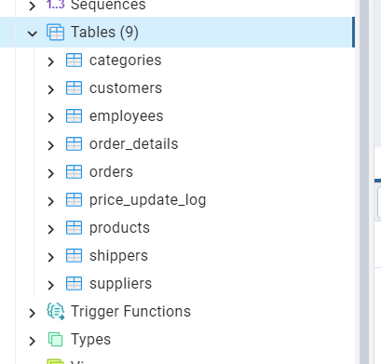

HOWEVER THERE IS TABLE SUPPLIERS WITH HomePage column and this is not email

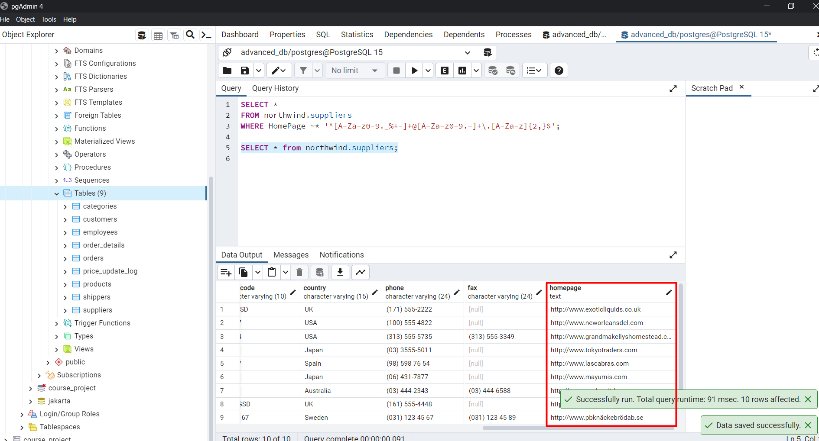

-- and it is returning just empty, however there is query for the email regex

